In consideration of being permitted to enter, and being fully knowledgeable of the risks of sailing as a competitive sport, the owner, contestants, and all crew members and guests aboard his/her yacht agrees to assume the risk of participation and to hold harmless all losses and/or claims incident thereto, the Grosse Ile Yacht Club, any of its officers, directors, members or sponsors and/or the personnel which conduct these races. All owners of participating yachts shall have insurance to insure against loss or damage of property and or injury to participating individuals and or yachts. I further agree to be bound by the Racing Rules of Sailing, the prescriptions of US Sailing, and by the Race’s Sailing Instructions. I further agree that all yachts entered or racing shall be subject to the direction and control of the Grosse Ile Yacht Club Race Committee. The establishment of special regulations and/or instructions in no way limits or reduces the complete and unlimited responsibility of the owner or owner's representative.

The safety of a yacht and its crew is the sole and inescapable responsibility of the skipper. It shall be the complete and unlimited responsibility of each skipper to decide whether to start, continue, or finish a race. Skippers must be a member of a yacht, sail club, or other organization affiliated with a national sailing authority. Crews who are competent and physically fit to face adverse conditions shall man all boats.

If races are canceled, for any reason, entry fees will not be refunded.

|  |  |  |  |  |  |  |  |  |  |  |  |  |  |  |  |  |
| --- | --- | --- | --- | --- | --- | --- | --- | --- | --- | --- | --- | --- | --- | --- | --- | --- |
| Signature: ____________________________________ | | | | | | | | Date: _______________ | | | | |  |  | |  |
|  |  |  |  |  |  |  |  | |  |  | |  | | |  |  | |
|  |  |  |  |  |  |  |  | |  |  | |  | | |  |  | |
| Payment: | |  |  |  |  |  |  | |  |  | |  | | |  |  | |
|  | Cash |  |  | Check |  |  | Online Payment | |  |  | GIYC Account # | | | |  |  | |
|  |  |  |  |  |  |  |  | |  |  | |  | | |  |  | |
| Mail to: Race Chairman @ 29677 E River Rd, Grosse Ile, MI 48138 or race@giyc.com | | | | | | | | | | | | | | | |  |

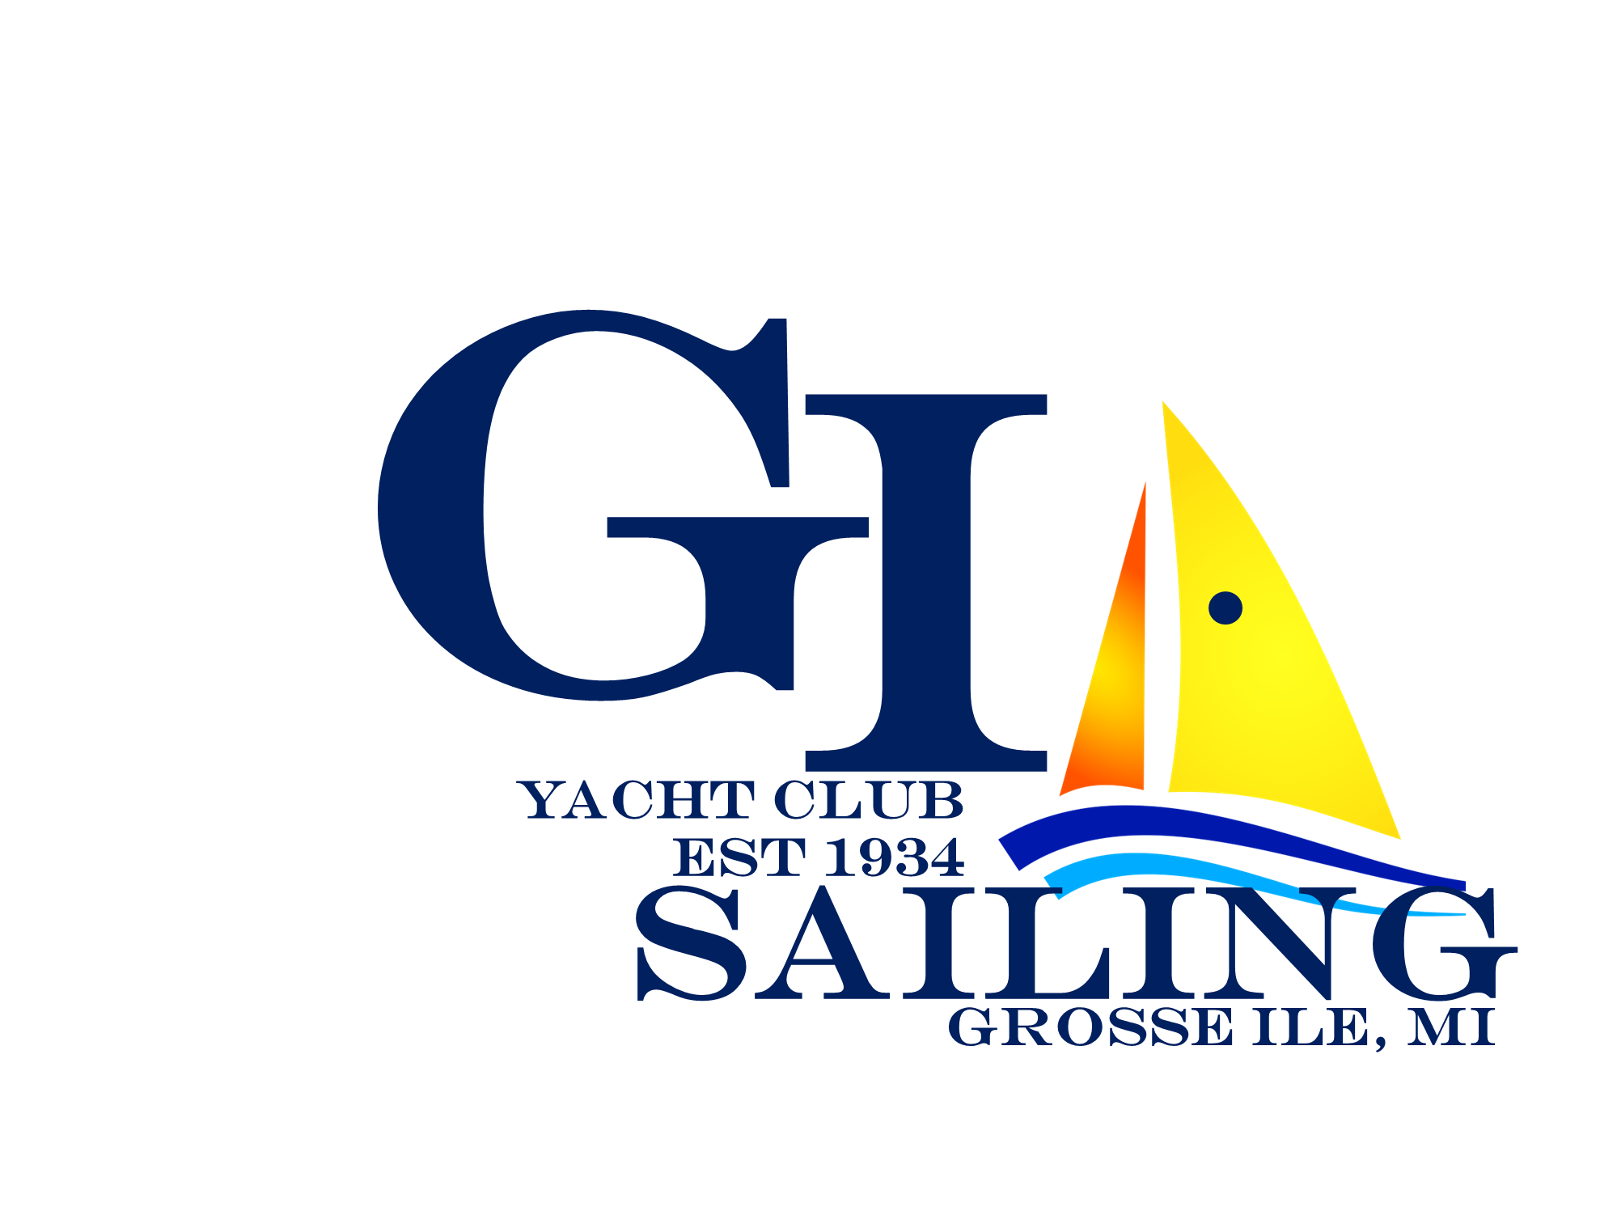

|  |  |  |  |  |  |  |  |
| --- | --- | --- | --- | --- | --- | --- | --- |
| 2023 ENTRY FORM  Fall Colors Regatta $50 | | | | | | | |
|
| Skipper Name |  |  |  |  |  |  |  |
| Email |  |  |  |  |  |  |  |
| Boat Name |  |  |  |  |  |  |  |
| Make/Model |  |  |  |  |  |  |  |
| Sail # |  |  |  | Yacht Club |  |  |  |
| Address |  |  |  |  |  |  |  |
| City |  |  |  | State |  |  |  |
| Zip |  |  |  | Phone |  |  |  |
| Insurance: |  |  |  | Exp. Date |  |  |  |